TIFF Viewer
Pluggable widget for Mendix Studio Pro 10.24.17
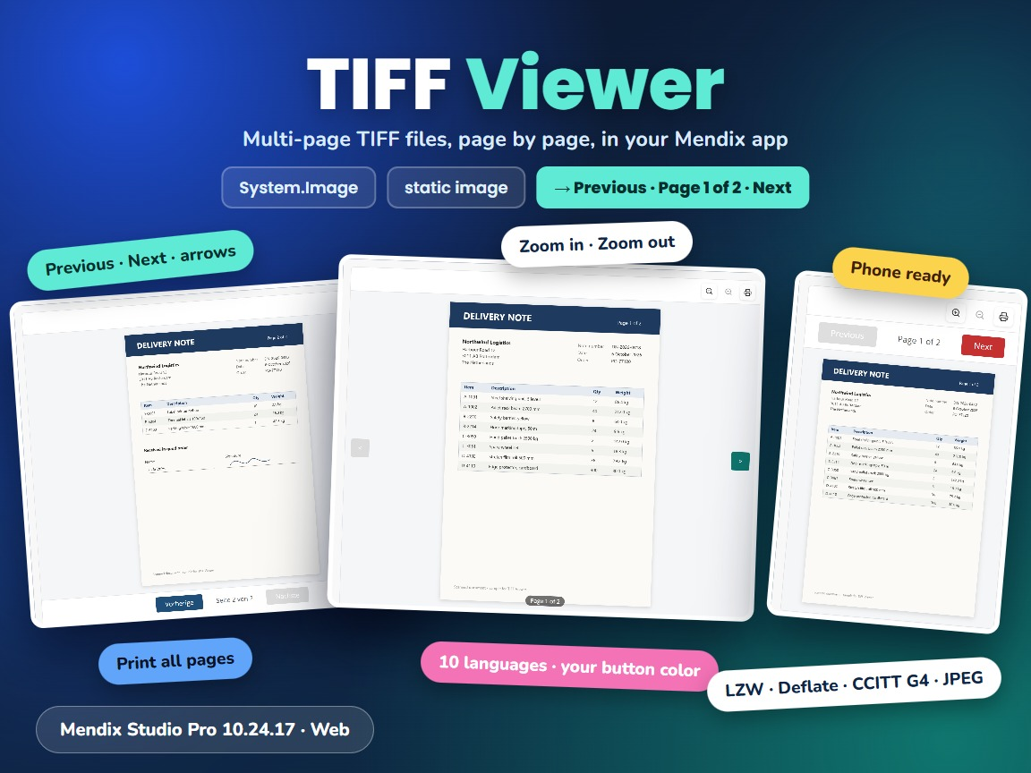
Item | Value
Widget version | 1.1.0
Studio Pro version | 10.24.17 (tested on 10.24.17.102810)
Widget ID | mxtechies.tiffviewer.TiffViewer
Widget package | mxtechies.TiffViewer.mpk (about 100 KB)
Platform | Web (offline capable)
TIFF library | utif2 4.1.0
Build tooling | @mendix/pluggable-widgets-tools 10.16.0
Source and downloads | github.com/bharathidas/TiffViewer

Contents

1. Overview
Browsers cannot show TIFF images in an image widget. TIFF Viewer decodes a TIFF file in the browser and shows it one page at a time. Multi-page files get Previous and Next buttons with the page number, and optional buttons let the user zoom in and out and print all pages of the file.
The image is an image property, like in the Mendix Image widget: a dynamic image (an object of System.Image or a specialization, from the data view) or a static image. The page buttons, their color and language, and the zoom and print buttons can be set with attributes, so they can change at run time.
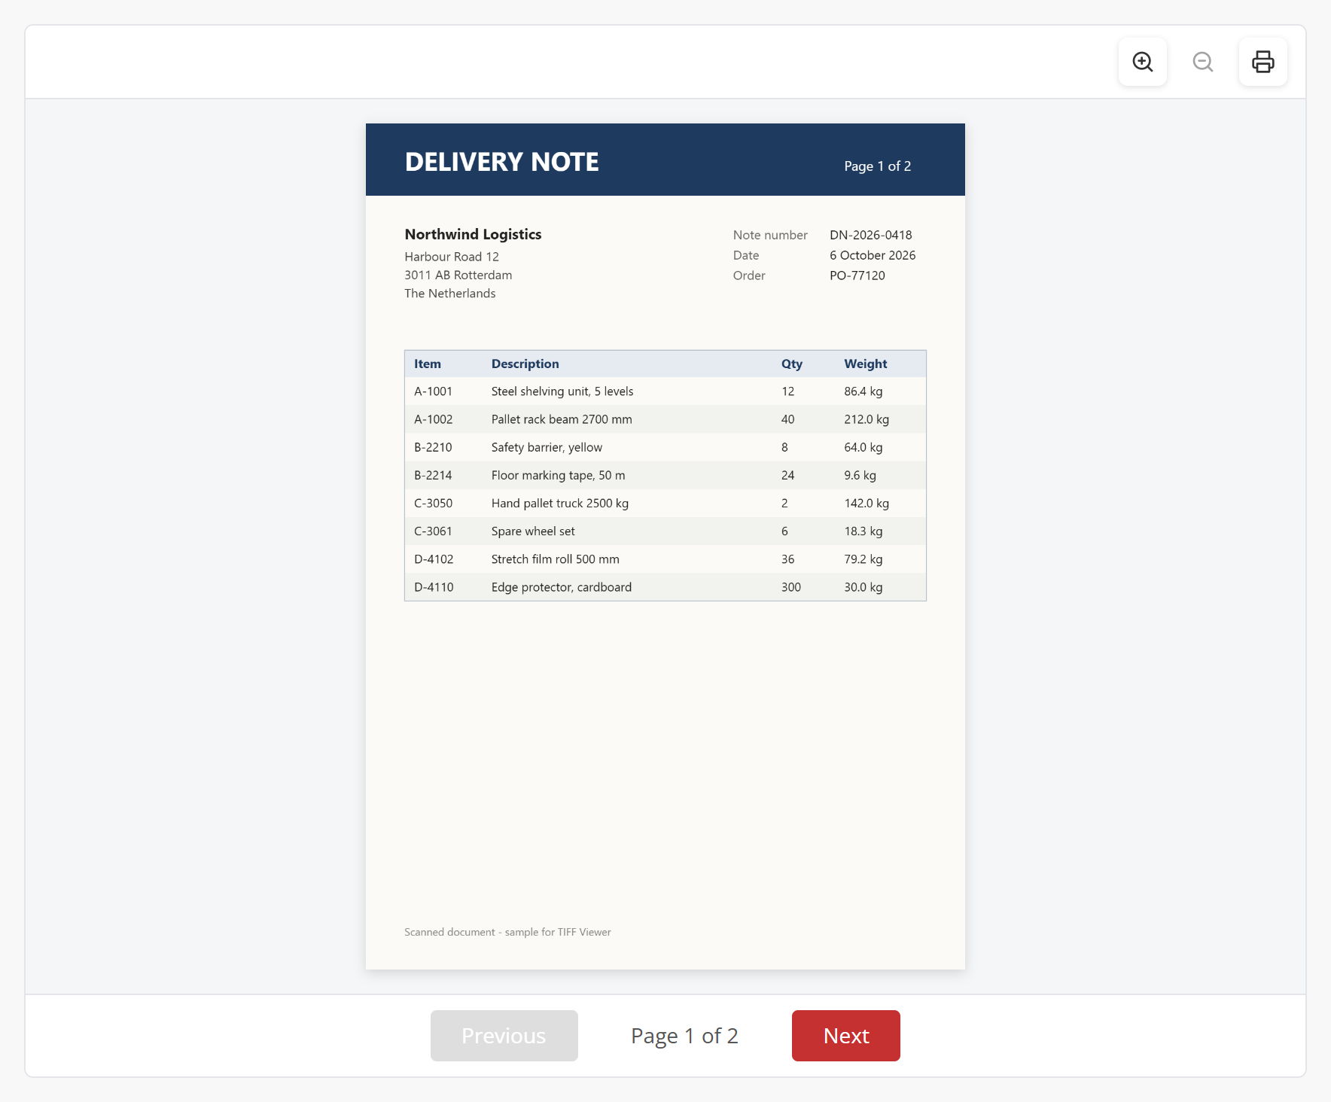
Figure 1. A two-page delivery note with the default settings

Typical uses
- Scanned documents such as delivery notes, invoices, contracts and forms that are stored as images
- Faxes, which are usually stored as multi-page TIFF files
- Technical drawings, plans and archive images in TIFF format
- Reviewing and printing an uploaded TIFF file before it is processed or approved

2. What is new in version 1.1.0
- Rebuilt for Mendix Studio Pro 10.24.17 with @mendix/pluggable-widgets-tools 10.16.0. The viewer no longer uses the react-tiff library; it decodes the files with utif2 4.1.0. The package is about 100 KB; version 1.0.0 was about 2 MB per bundle (react-tiff with axios and i18next). The look and the properties are the same.
- Print prints only the pages of the TIFF file, every page on its own sheet. In 1.0.0 it printed the whole Mendix page.
- Zoom works in steps of 1.25x, from the fitted size up to 5x; the page scrolls when it is larger than the viewer. In 1.0.0 the zoom and print buttons were covered by the page layout so they could not be clicked, and Zoom out stopped working after zooming in.
- Page buttons top and ltr work, and the value ignores case and spaces. In 1.0.0 top hid the page buttons and ltr (the value in the Studio Pro description) showed them at the bottom.
- Language: en, de, fr, es, tr, ja, zh, ru, ar and hi; fr-FR is read as fr, and the zoom and print buttons are translated too. 1.0.0 knew five languages and needed an exact match.
- New Height property (default 600px; a number without a unit is read as pixels). 1.0.0 was always 600px high.
- The page is fitted to the viewer and fitted again when the viewer changes size.
- Files from another server load when that server allows CORS, whatever content type it sends. 1.0.0 showed nothing when the content type did not contain "tiff".
- When the image changes (for example another object in the data view), the new file is shown. The react-tiff viewer of 1.0.0 kept showing the first file.
- Clear error messages: The file is not a valid TIFF image. and the HTTP status (for example 404) when the file cannot be loaded. 1.0.0 showed an empty box.
- Reduced-resolution thumbnails stored in a TIFF are no longer shown as an extra page.
- Without a Button color the page buttons are #c53030, the color in the example of the description. 1.0.0 showed plain grey buttons.
- The class and style set in Studio Pro are applied. No messages in the browser console. Studio Pro design mode shows a placeholder. Clearer captions and descriptions. The widget ID and property keys are unchanged, so existing pages keep their settings.
Version 1.1.0 was tested in a Mendix 10.24.17 app with 35 automated checks; version 1.0.0 fails 15 of them. The checks cover the page buttons (bottom, top, ltr), Previous and Next, languages, button color, zoom in and out, print, the zoom and print attributes, the Height property, thumbnails, a 2400 x 3200 page, a non-TIFF file, a missing file, a file on another server, class and style, and a phone-sized window. The screenshots in this document are from that test app.

3. Requirements
- Mendix Studio Pro 10.24.17 or a later 10.24 version.
- A web profile. The widget is not available for native mobile.
- For a dynamic image: the widget must be inside a data view (or another widget that gives an object) of an entity that is System.Image or a specialization of it. No other modules are needed.

4. Installation

4.1 Install the widget
- Download mxtechies.TiffViewer.mpk from the Mendix Marketplace or from the GitHub release Version1.1.0.
- Copy the file into the widgets folder of your app. To find the folder, use App > Show App Directory in Explorer in Studio Pro.
- In Studio Pro, choose App > Synchronize App Directory (F4).
- The widget appears in the Toolbox as TIFF Viewer (category Display).

4.2 Upgrade from version 1.0.0
- Replace mxtechies.TiffViewer.mpk in the widgets folder with the 1.1.0 file.
- Synchronize the app directory (F4).
- Studio Pro reports that the widget definition has changed. Right-click the error and choose Update all widgets. Your settings are kept; the new Height property gets 600px.
- If the running app still shows the old widget, stop it, choose App > Clean Deployment Directory, and run it again.
Check after upgrading: without a Button color attribute the page buttons are now #c53030 (1.0.0: grey). If Page buttons is top, the buttons now appear above the page (1.0.0 showed no buttons).

5. Configuration

5.1 Show an uploaded TIFF file
- Create an entity that specializes System.Image, for example MyModule.ScannedDocument, or use an existing one.
- Let users upload TIFF files with an image uploader or file manager on a page of that entity. Allow the file extensions .tif and .tiff.
- Put a data view of that entity on the page that shows the file.
- Drag TIFF Viewer from the Toolbox into the data view.
- On the General tab, set TIFF image to Dynamic image and select the data view object.
- Optional: set Height, and select attributes for Page buttons, Button color, Language (String), Show zoom buttons and Show print button (Boolean).
The user needs read access to the image object (entity access); otherwise the server answers 401 or 404 and the widget shows the HTTP status.

5.2 Recommended settings
Use | Settings
Document review on a detail page | Height 700px, Page buttons bottom, zoom and print shown
Compact preview in a card | Height 320, Page buttons ltr, Show zoom buttons and Show print button false
Full-screen review in a pop-up | Height 80vh, Page buttons top
Users in another language | Language attribute from the user's language, for example de or fr-FR
Phone | Height 70vh, Page buttons top

Page buttons, Button color, Language and the two Boolean properties are attributes, as in 1.0.0. Give them a default value in the domain model (for example bottom and #1f4e79) or set them in the microflow or nanoflow that creates the object.

6. Property reference

General – Image
Property | Type | Description (default)
TIFF image | Image | The TIFF file: a dynamic image (System.Image or a specialization) or a static image. Required.

General – Display
Property | Type | Description (default)
Height | Text | CSS height, for example 600px, 80vh or 30rem. A number without a unit is read as pixels. (600px) The width is always the width of the container.
Page buttons | String attribute | bottom: Previous, page number and Next below the page; top: above the page; ltr: arrows left and right of the page with the page number below it. Case and spaces are ignored. Shown for files with more than one page. (bottom)
Button color | String attribute | CSS color of the page buttons, for example #1f4e79 or teal. (#c53030)
Language | String attribute | Language of the button texts: en, de, fr, es, tr, ja, zh, ru, ar or hi. A code such as fr-FR is read as fr; an unknown value uses English. (en)

General – Buttons
Property | Type | Description (default)
Show zoom buttons | Boolean attribute | True shows Zoom in and Zoom out, false hides them. (No attribute selected: shown)
Show print button | Boolean attribute | True shows Print, false hides it. Print prints all pages of the file. (No attribute selected: shown)

Common and Visibility
Property | Type | Description
Name | System | Name of the widget; also gives the class mx-name-<name>.
Class and Style | System | Applied to the outer box of the widget.
Visibility | System | Default or Conditionally.

7. Examples
Figure 2. Default settings: page buttons below the page, zoom and print
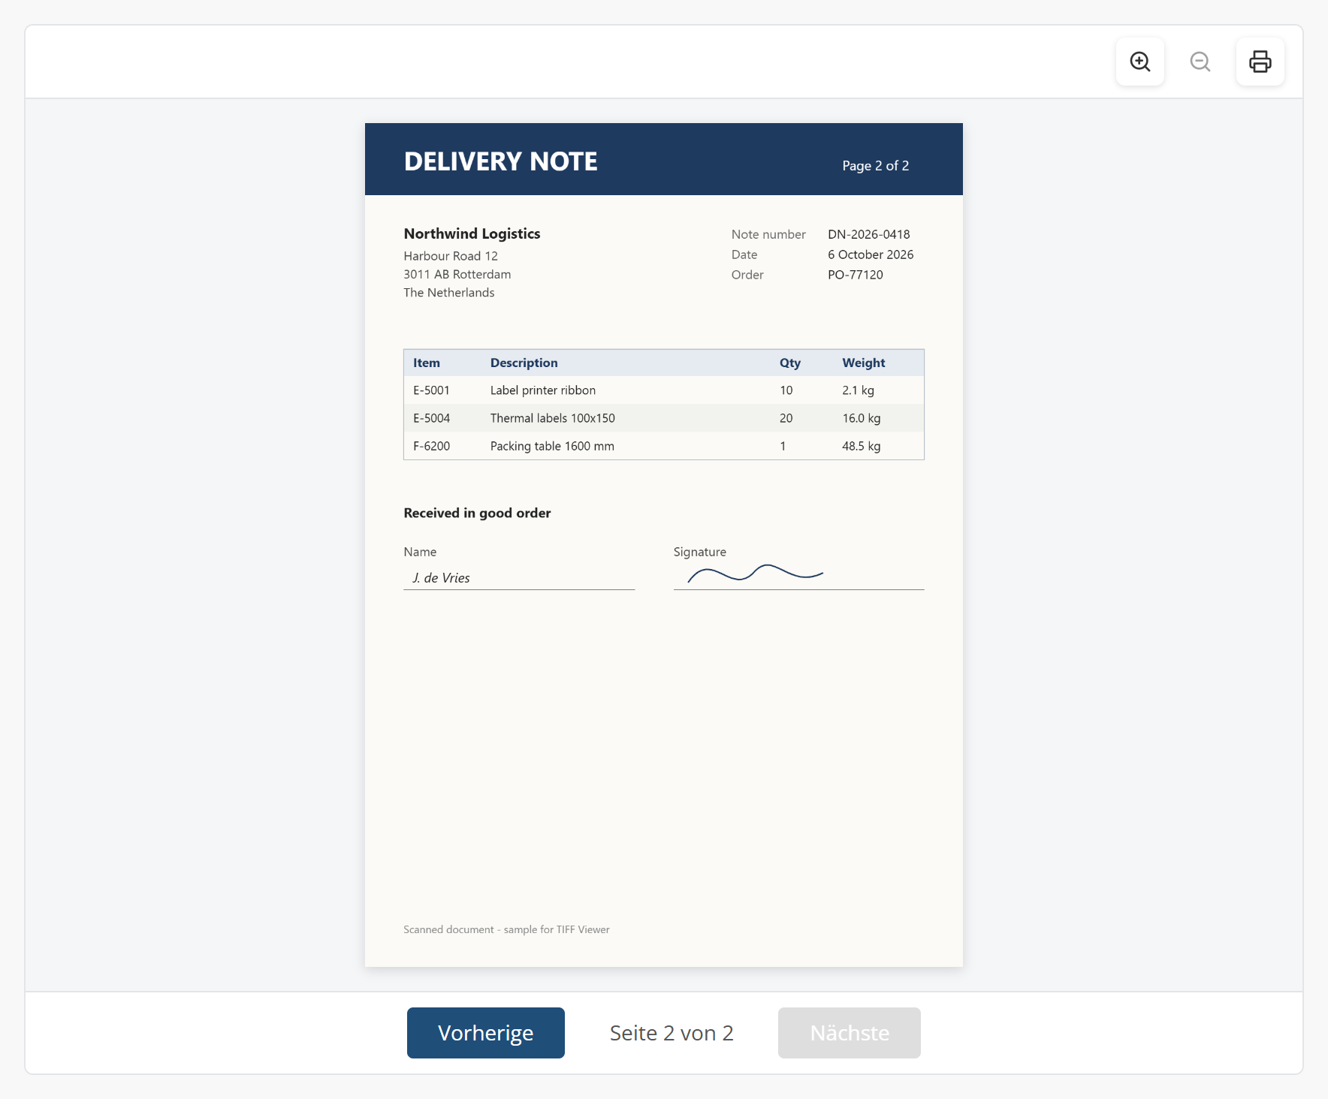
Figure 3. Language de and Button color #1f4e79, second page
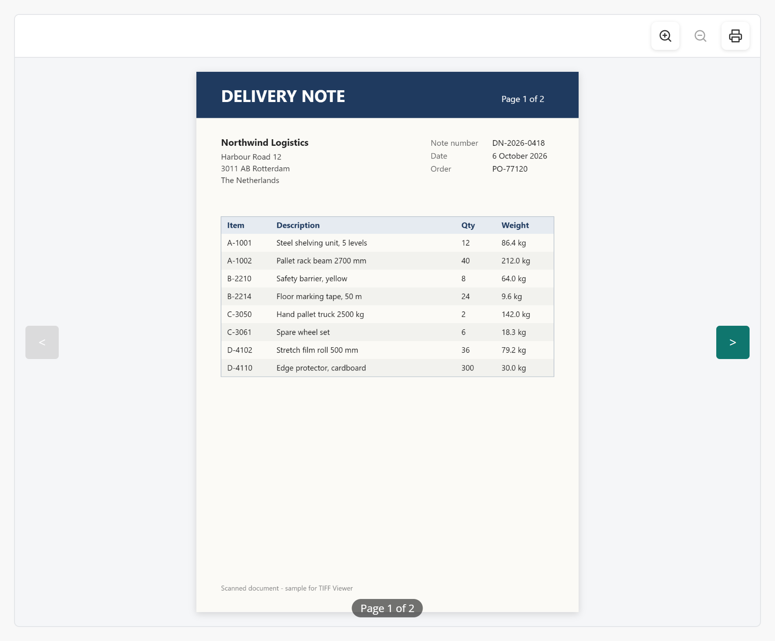
Figure 4. Page buttons ltr with Button color #0f766e
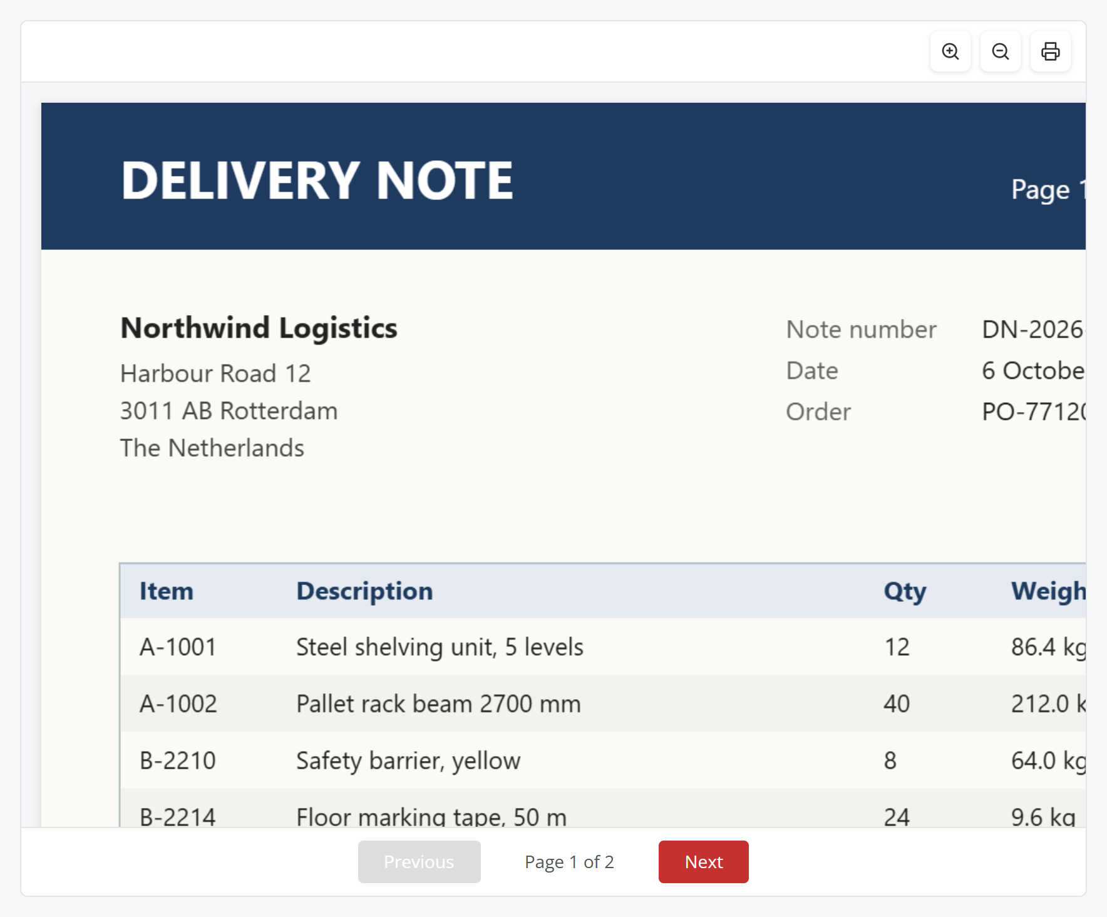
Figure 5. After Zoom in four times: the page scrolls
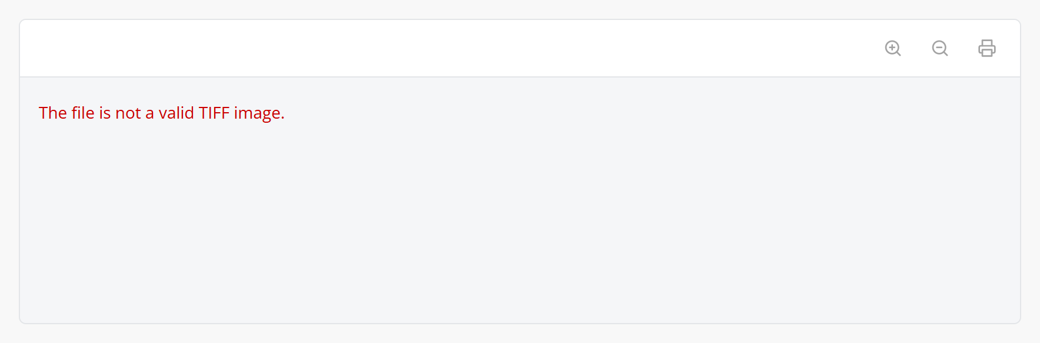
Figure 6. A file that is not a TIFF image shows an error message
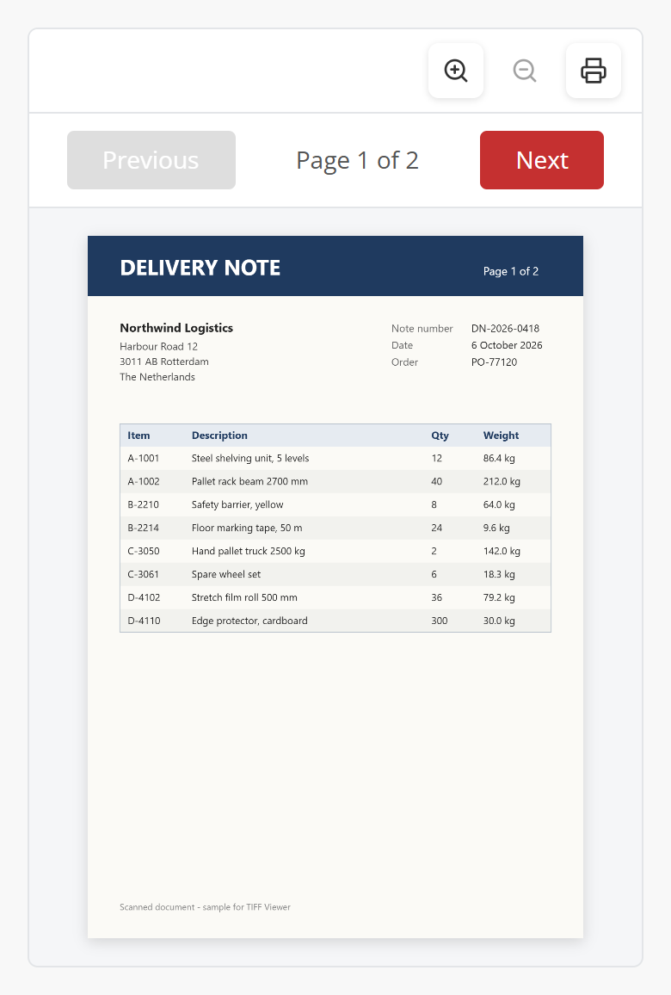
Figure 7. Phone width with Height 70vh and Page buttons top

8. Styling
The widget renders these elements. The class and style from Studio Pro are applied to the outer element.
<div class="widget-tiffviewer mx-name-tiffViewer1 your-class">
<div class="widget-tiffviewer-toolbar">
<button class="widget-tiffviewer-tool widget-tiffviewer-zoom-in">
... widget-tiffviewer-zoom-out, widget-tiffviewer-print ...
</div>
<div class="widget-tiffviewer-pager widget-tiffviewer-pager-top"> (top)
<div class="widget-tiffviewer-area">
<div class="widget-tiffviewer-stage">
<canvas class="widget-tiffviewer-page"></canvas>
</div>
<button class="widget-tiffviewer-arrow ..."> (ltr)
</div>
<div class="widget-tiffviewer-pager widget-tiffviewer-pager-bottom">
<button class="widget-tiffviewer-page-button">Previous</button>
<span class="widget-tiffviewer-page-number">Page 1 of 2</span> ...
</div>
</div>
Example theme classes: no border, a darker page area and round page buttons.
.widget-tiffviewer { border: 0; border-radius: 0; }
.widget-tiffviewer-stage { background: #e9ecef; }
.widget-tiffviewer-page-button { border-radius: 999px; }

9. Known behaviour and limitations
- Web only; not available in native mobile apps.
- The whole file is loaded and every page is decoded in the browser. Very large files (hundreds of MB, or many pages of high resolution) take time and memory.
- Most TIFF compressions are supported by utif2 (none, LZW, PackBits, Deflate, CCITT fax G3/G4, JPEG). Rare variants that utif2 cannot decode show an error message.
- One page is shown at a time; there is no thumbnail list or rotation.
- Print opens the print dialog of the browser for the pages of the file; the browser decides the paper size and margins.
- The fitted size can be larger than the original size for small images.
- Messages such as Loading TIFF... and the error messages are in English.
- Studio Pro design mode shows a placeholder, because a dynamic image is only known at run time.

10. Support and version history
Report issues, suggestions and feature requests on GitHub:
https://github.com/bharathidas/TiffViewer/issues
Source code and all releases:
https://github.com/bharathidas/TiffViewer
Widget | Studio Pro | GitHub release | Changes
1.1.0 | 10.24.17 | Version1.1.0 | Rebuilt for Studio Pro 10.24.17 without react-tiff; print only the TIFF pages; working zoom; page buttons top and ltr; ten languages; Height property; refit on resize; CORS files with any content type; new file shown when the image changes; clear error messages; thumbnails skipped; class and style applied; no console messages; design-mode placeholder; package about 100 KB.
1.0.0 | 10.18.3 | V1.0.0 | First release.

